Installation steps

Apache maven

Download the Apache maven binary.

<https://maven.apache.org/download.cgi>

add to environment variables.

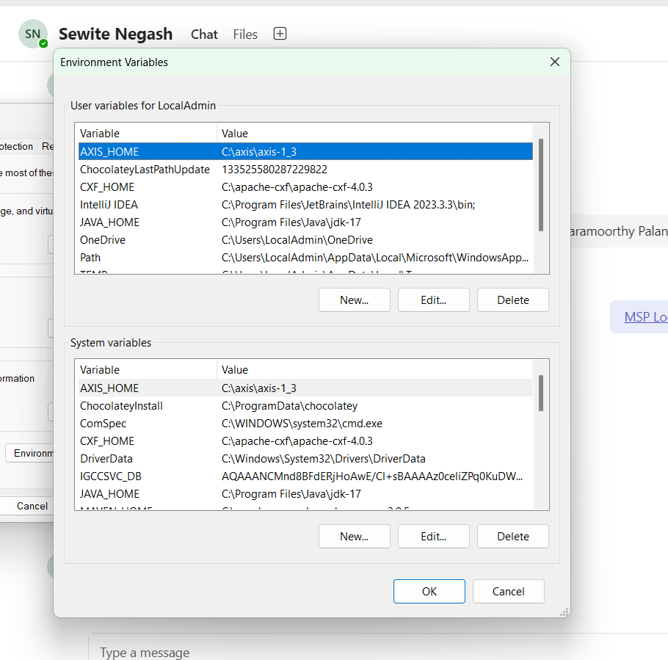

Visual studio installation

<https://code.visualstudio.com/download>

Install some extensions for VS code

**Spring Initializr Java Support**

**Spring Boot Tools**

**Spring Boot Extension Pack**

**Spring Boot Dashboard**

**Red Hat Dependency Analytics**

**Project Manager for Java**

**Maven for Java**

**Java Debugger**

**Java + Spring Extension Pack**

**Extension Pack for Java**

**Docker**

To create the first project, you can use VS code or spring initializer

<https://start.spring.io/>

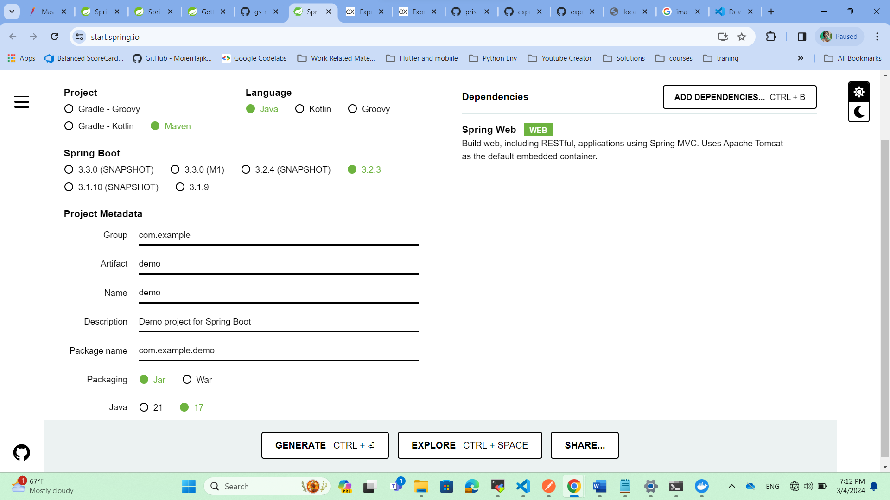

Using VS code

1. Prese Ctrl + shift + P select java: Create Java Project  
     
   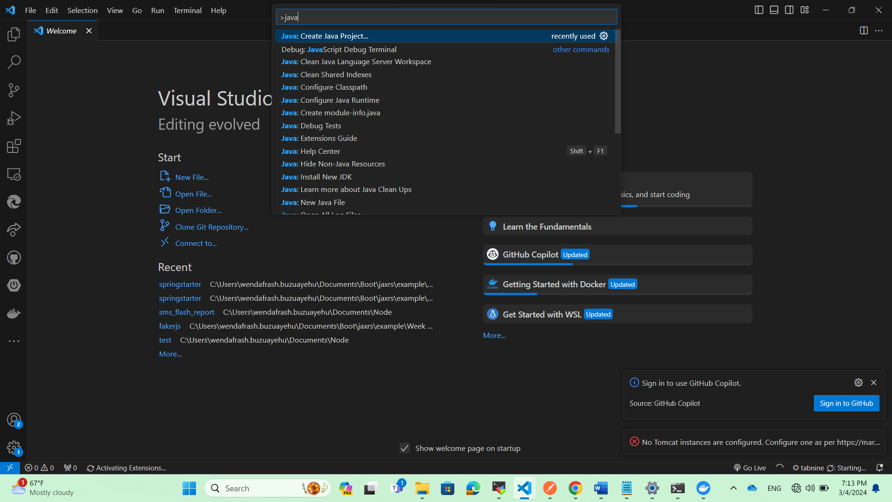
2. Then select spring boot 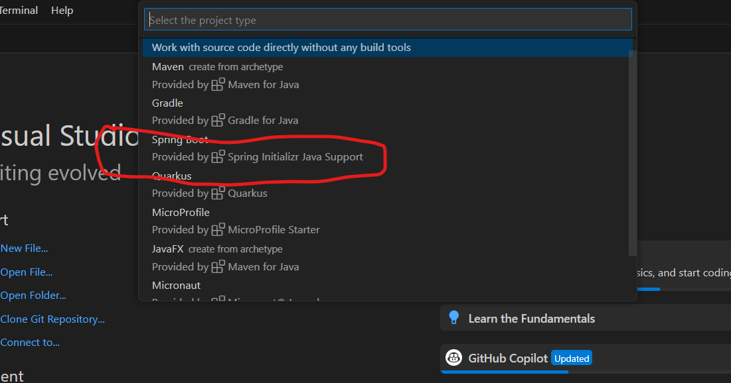
3. Then select Maven Project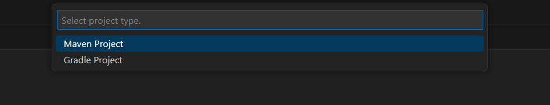
4. Then select the version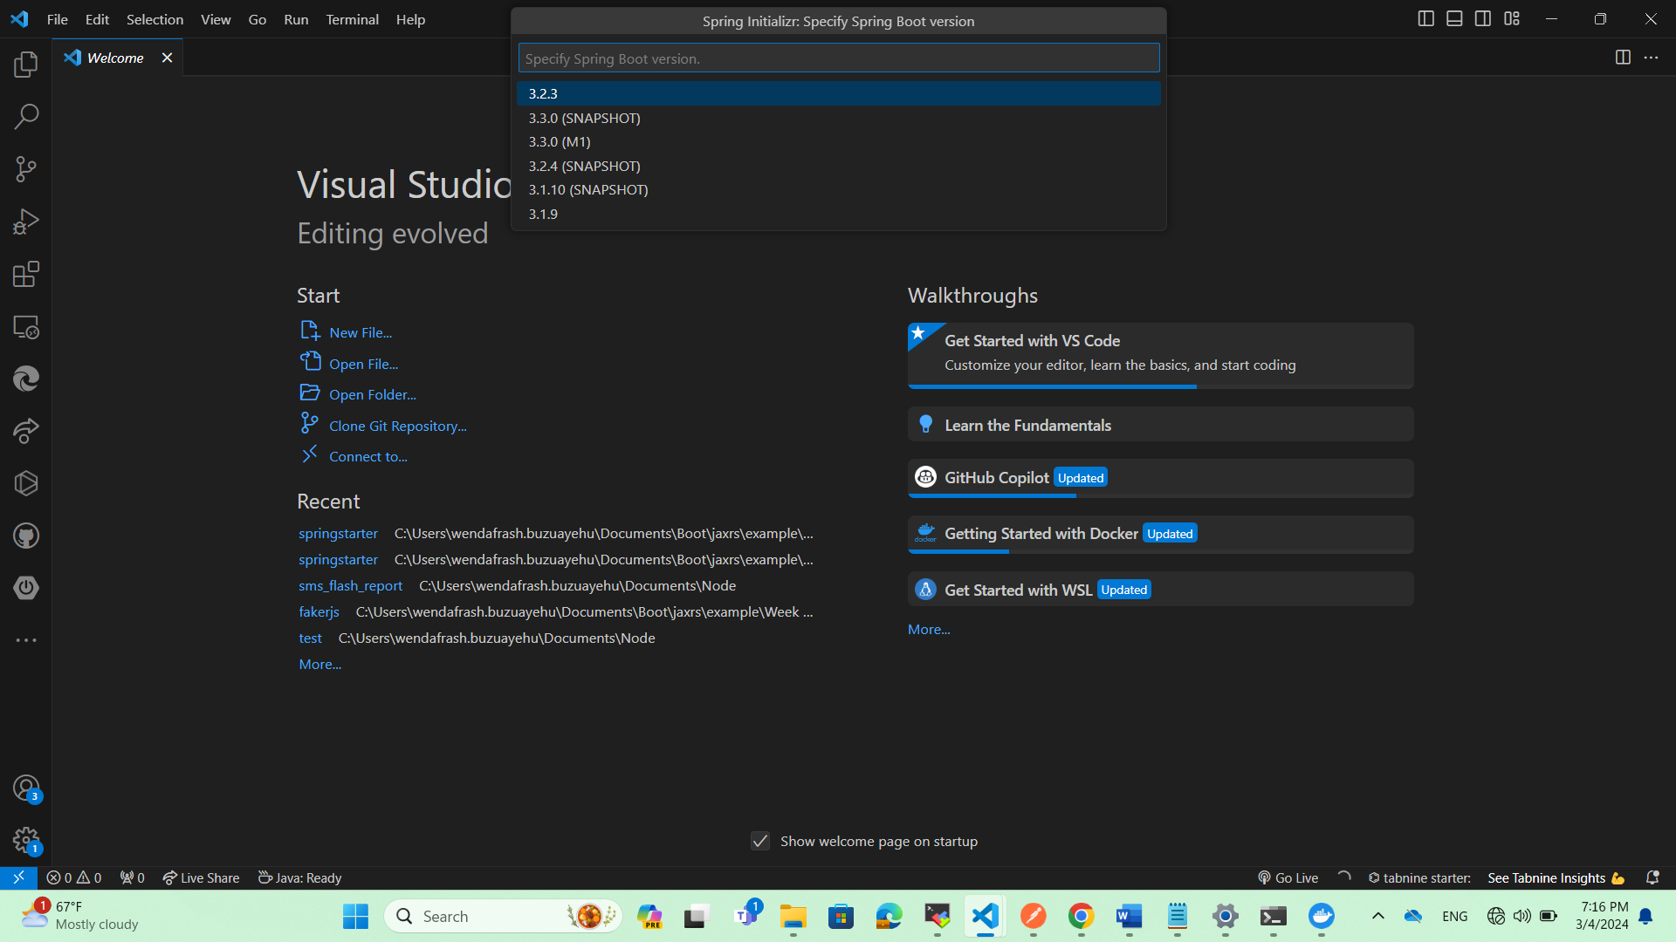
5. Then select language JavaA screenshot of a computer

   Description automatically generated
6. Add your group Id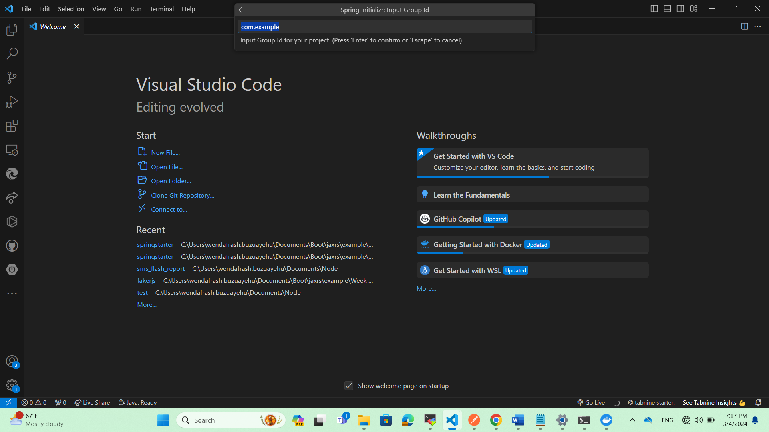
7. Then Artifact Id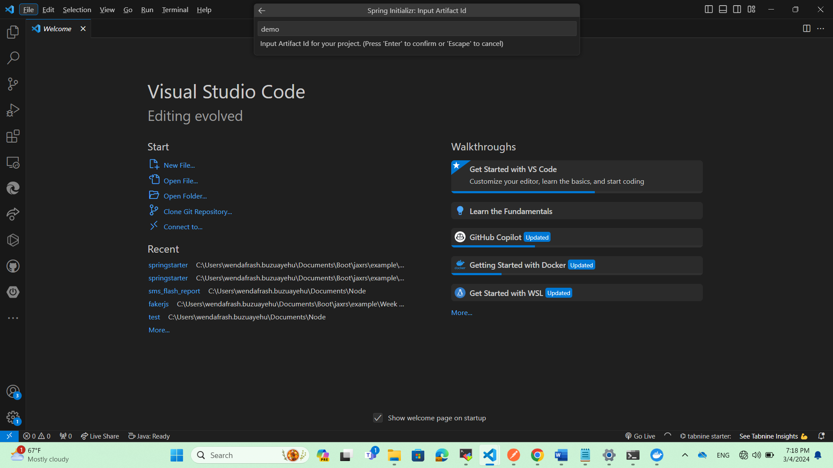
8. Then select packaging type JarA screenshot of a computer

   Description automatically generated
9. Java versionA screenshot of a computer

   Description automatically generated
10. Add dependency like spring web, lombok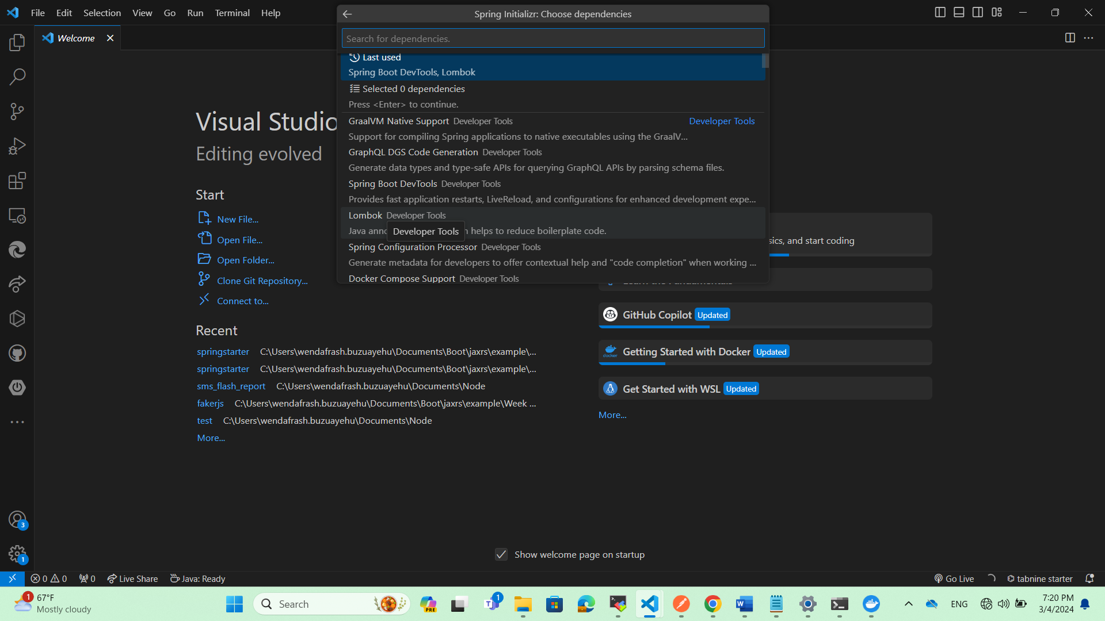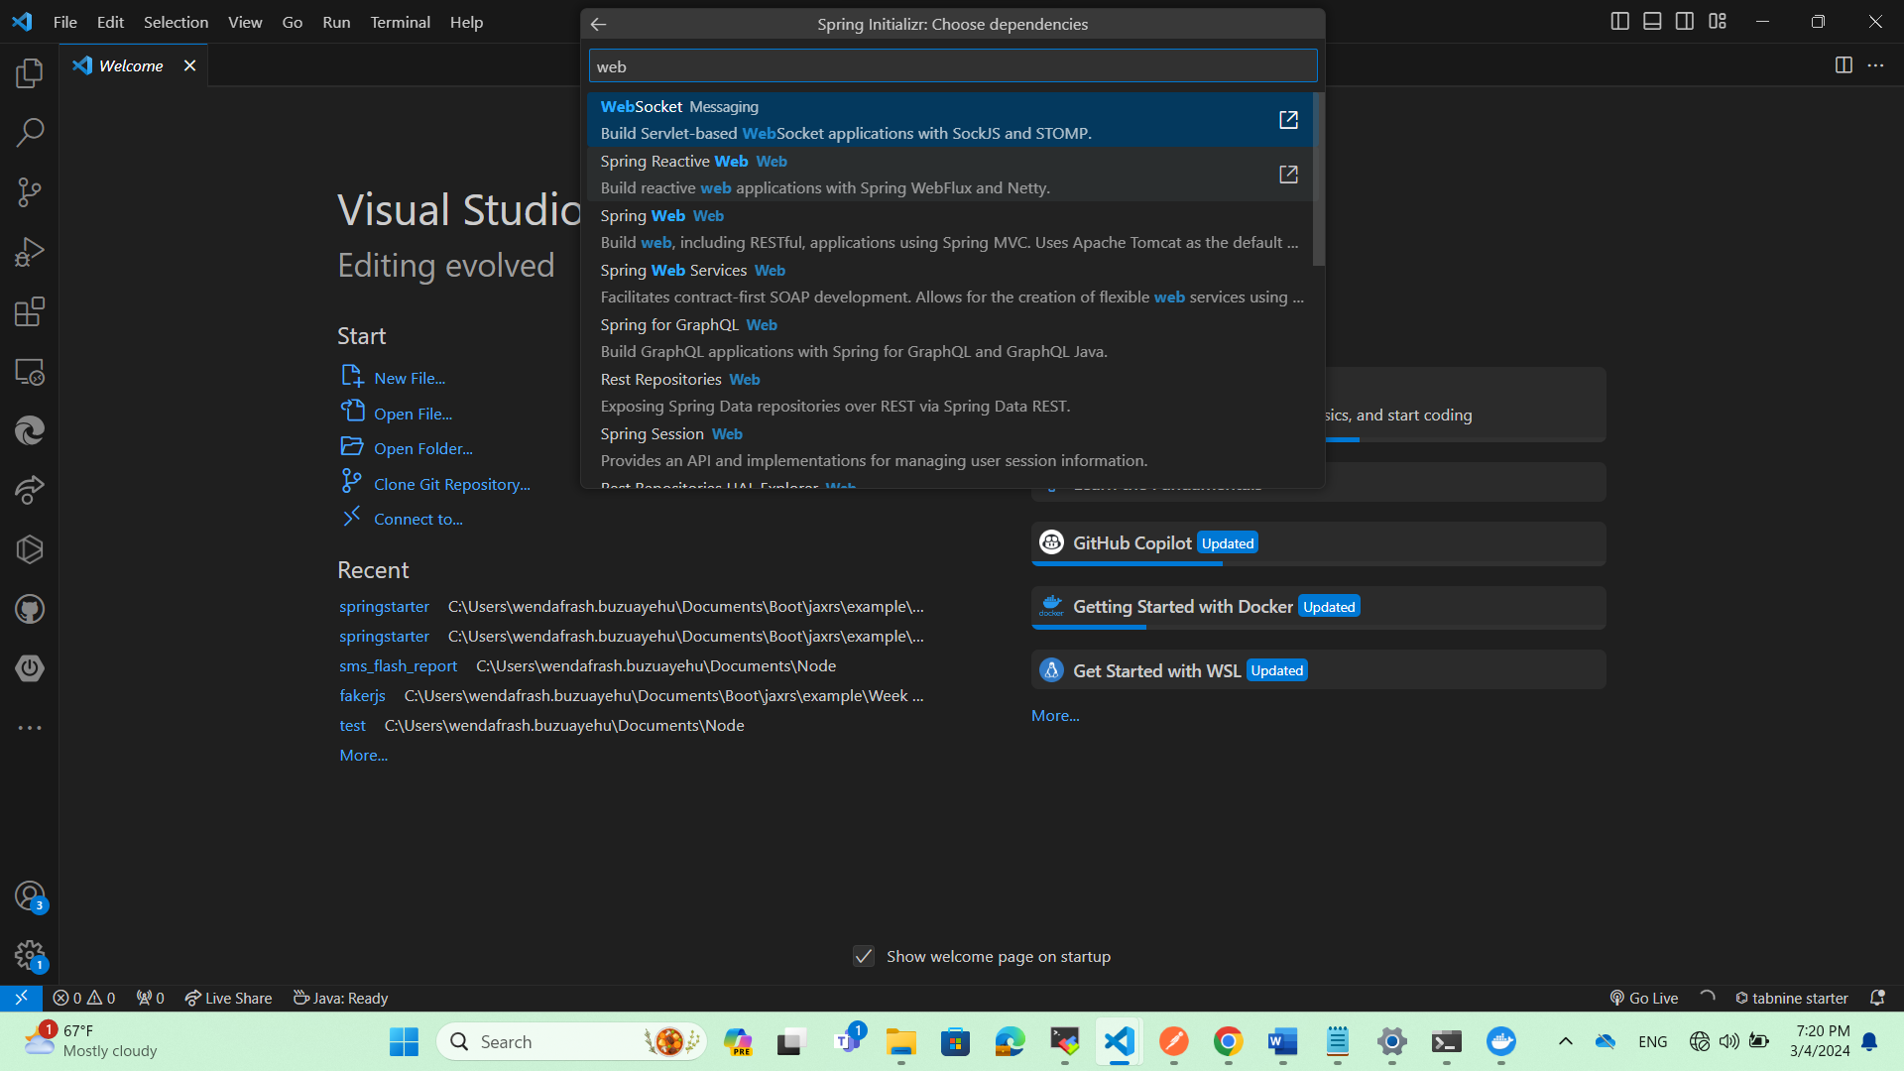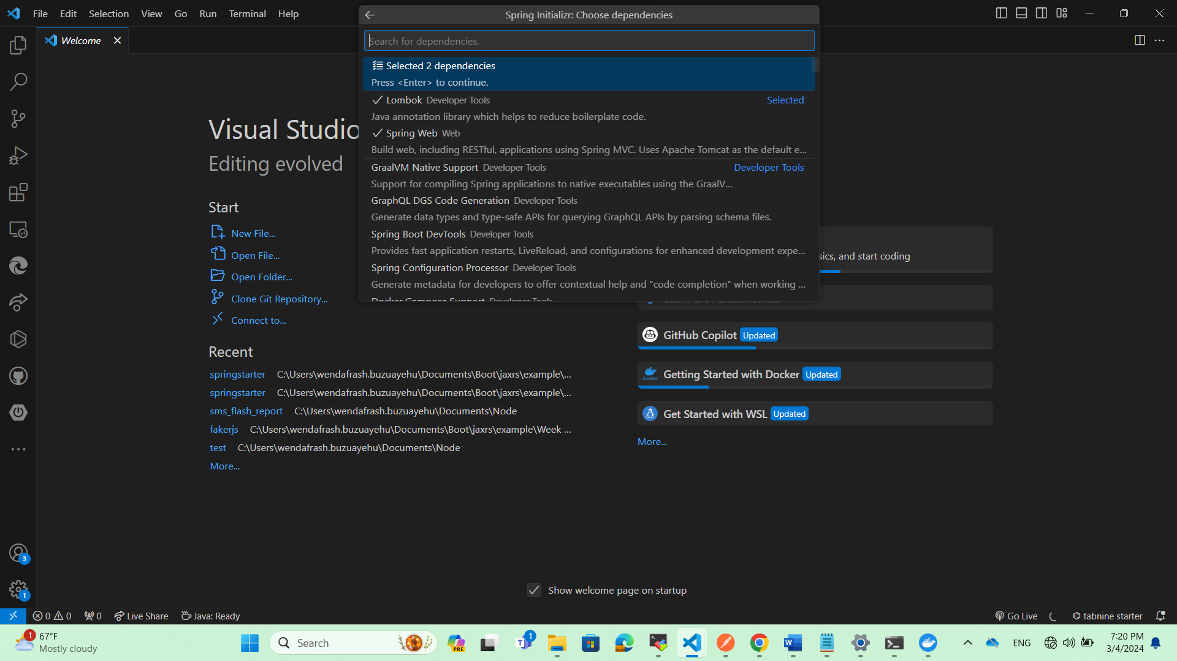
11. Then select your desire folder location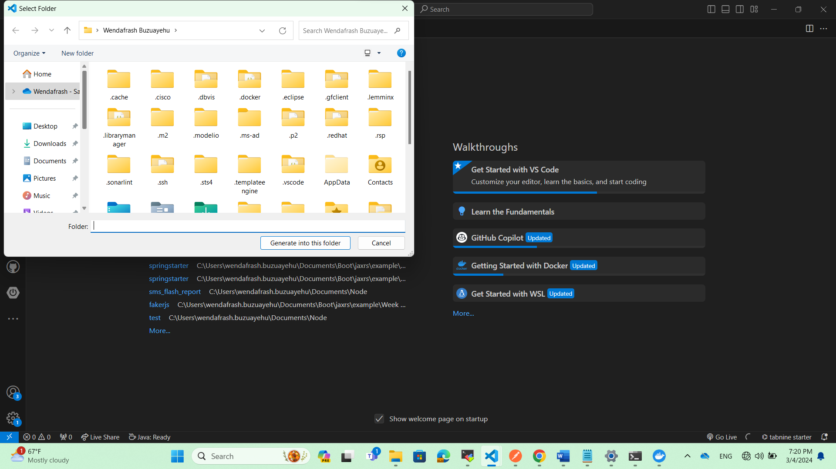
12. Then it will generate the code in the folder and will prompt 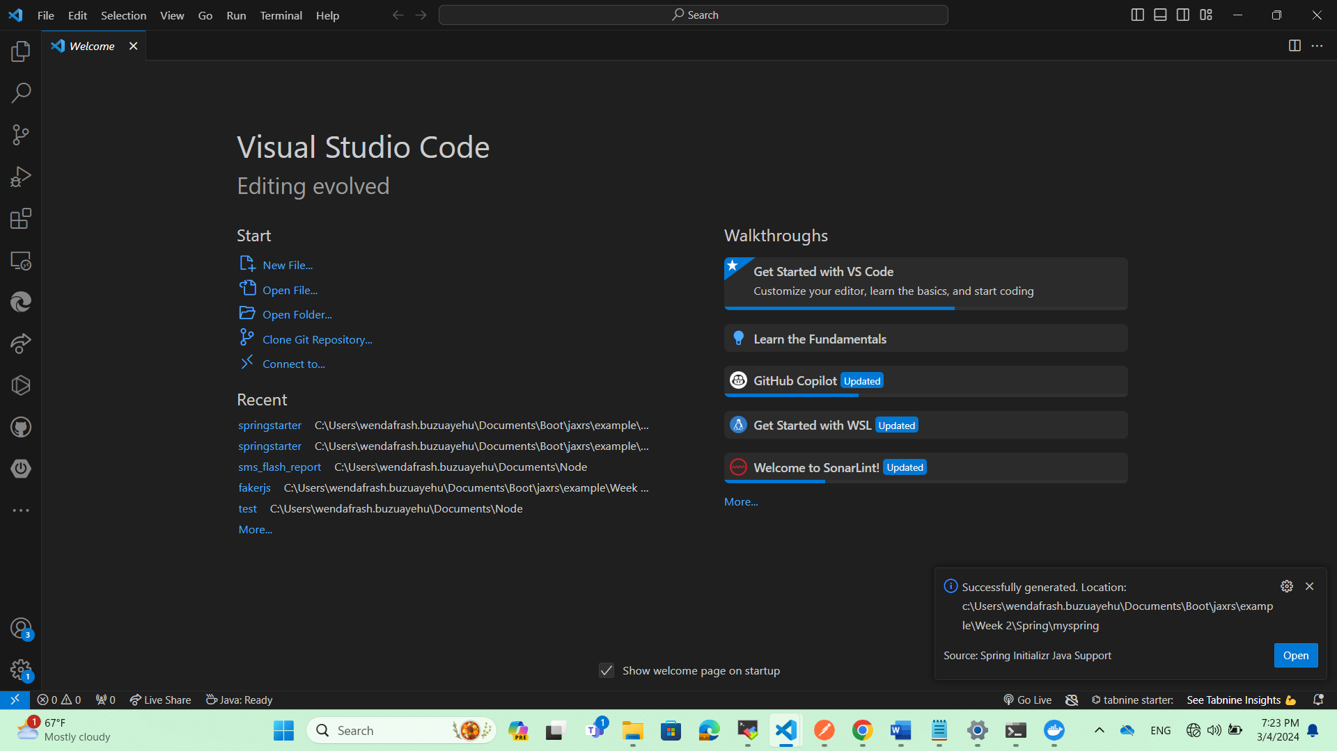
13. 